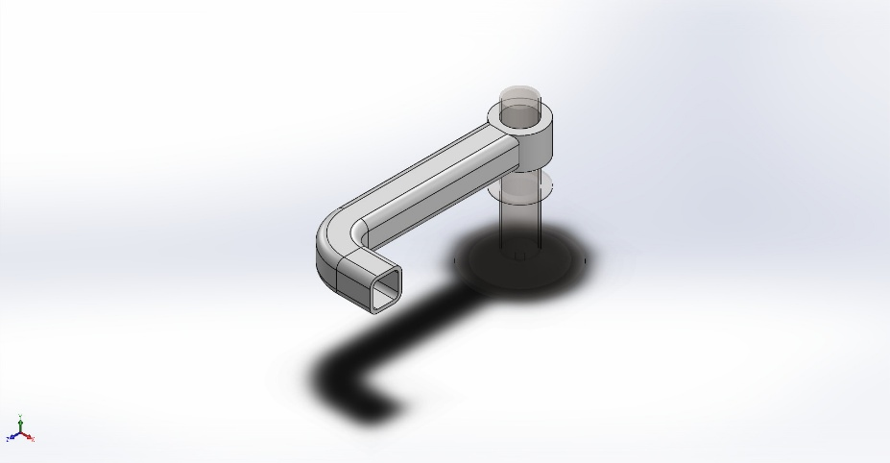 | Simulation of Contact  Date: April 28, 2026  Designer: Remy  Study name: Nonlinear 1  Analysis type: Nonlinear - Dynamic  Table of Contents  Description 1  Assumptions 2  Model Information 2  Study Properties 3  Units 4  Material Properties 4  Loads and Fixtures 5  Connector Definitions 6  Interaction Information 6  Mesh information 7  Sensor Details 9  Resultant Forces 9  Beams 9  Study Results 10  Conclusion 14

Description
No Data

Assumptions

Model Information

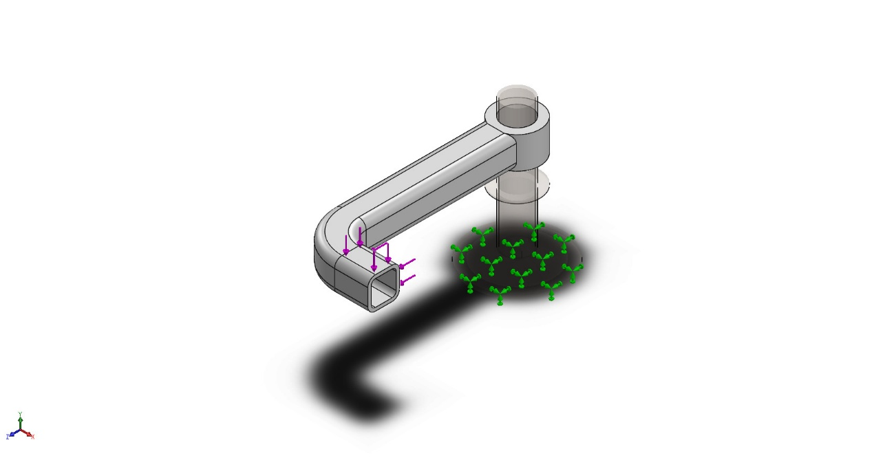
Model name: Contact
Current Configuration: Default
Solid Bodies
Document Name and Reference | Treated As | Volumetric Properties | Document Path/Date Modified
Imported1  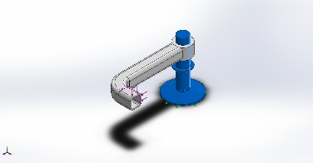 | Solid Body | Mass:1.75994 kg  Volume:0.000228563 m^3  Density:7,700 kg/m^3  Weight:17.2474 N | C:\Users\26869\Desktop\game\Solidwork\resource\model\第61课\Metal.SLDPRT
Imported1  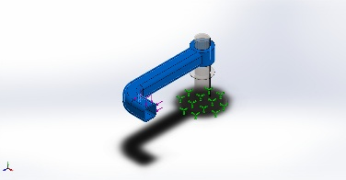 | Solid Body | Mass:0.401324 kg  Volume:0.000393455 m^3  Density:1,020 kg/m^3  Weight:3.93297 N | C:\Users\26869\Desktop\game\Solidwork\resource\model\第61课\Rubber-1.SLDPRT

Study Properties
Study name | Nonlinear 1
Analysis type | Nonlinear - Dynamic
Mesh type | Solid Mesh
Start time | 0 Seconds
End time | 0.08 Seconds
Time increment | Auto stepping
Compute free body forces | Off
Contact penalty stiffness scale factor | 1
Large displacement formulation: | On
Update load direction with deflection: | Off
Large strain formulation: | Off
Save data for restarting the analysis | Off
Thermal Effect: | On
Thermal option | Include temperature loads
Zero strain temperature | 298 Kelvin
Solver type | Large Problem Direct Sparse
Incompatible bonding options | Simplified
Control technique: | Force
Iterative technique: | NR(Newton-Raphson)
Integration Method | Newmark
Result folder | SOLIDWORKS document (C:\Users\26869\Desktop\game\Solidwork\resource\model\第61课)

Units
Unit system: | SI (MKS)
Length/Displacement | mm
Temperature | Kelvin
Angular velocity | Rad/sec
Pressure/Stress | N/m^2

Material Properties
Model Reference | Properties | Components
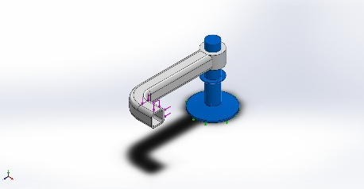 | Name: Alloy Steel  Model type: Linear Elastic Isotropic  Default failure criterion: Unknown  Yield strength: 6.20422e+08 N/m^2  Tensile strength: 7.23826e+08 N/m^2  Elastic modulus: 2.1e+11 N/m^2  Poisson's ratio: 0.28  Mass density: 7,700 kg/m^3  Shear modulus: 7.9e+10 N/m^2  Thermal expansion coefficient: 1.3e-05 /Kelvin | SolidBody 1(Imported1)(Metal-1)
Curve Data:N/A
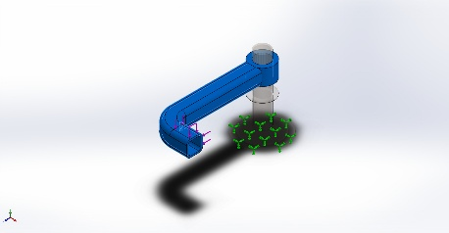 | Name: ABS  Model type: Plasticity - von Mises  Default failure criterion: Unknown  Yield strength: 3e+07 N/m^2  Tangent modulus: 0 N/m^2  Elastic modulus: 2e+09 N/m^2  Poisson's ratio: 0.394  Mass density: 1,020 kg/m^3 | SolidBody 1(Imported1)(Rubber-1-1)
Curve Data:N/A

Loads and Fixtures
Fixture name | Fixture Image | Fixture Details
Fixed-1 | 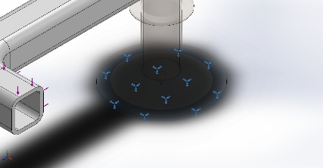 | Entities: 1 face(s)  Type: Fixed Geometry
Resultant Forces
Components | X | Y | Z | Resultant
Reaction force(N) | 298.014 | 135.727 | -116.037 | 347.417
Reaction Moment(N.m) | 0 | 0 | 0 | 0

Symmetry-1 | 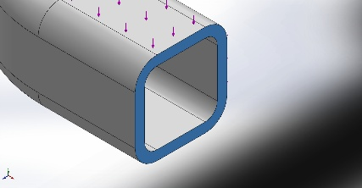 | Entities: 1 face(s)  Type: Symmetry
Resultant Forces
Components | X | Y | Z | Resultant
Reaction force(N) | 85.7543 | 0 | 0 | 85.7543
Reaction Moment(N.m) | 0 | 0 | 0 | 0

Load name | Load Image | Load Details
Force-1 | 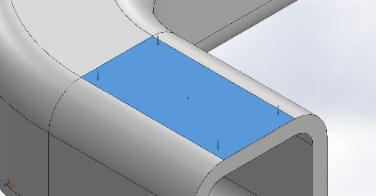 | Entities: 1 face(s)  Type: Apply normal force  Value: 125 N
Force-2 | 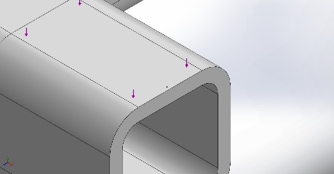 | Entities: 1 face(s)  Type: Apply normal force  Value: 550 N

Connector Definitions
No Data

Interaction Information

Interaction | Interaction Image | Interaction Properties
Local Interaction-1 | 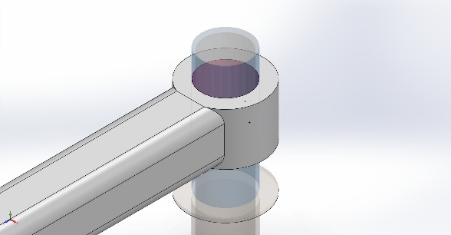 | Type: Contact interaction pair  Entities: 2 face(s)  Advanced: Surface to surface
Contact/Friction force
Components | X | Y | Z | Resultant
Contact Force(N) | 2.9969E-12 | 7.6393E-16 | -2.466E-12 | 3.8811E-12

Local Interaction-2 | 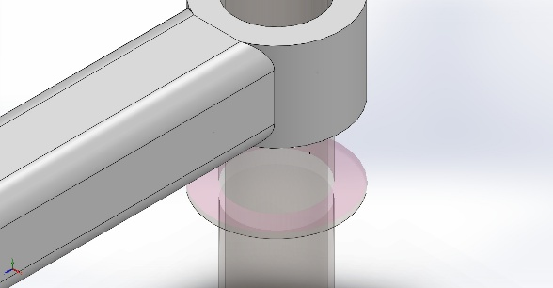 | Type: Contact interaction pair  Entities: 3 face(s)  Advanced: Surface to surface
Contact/Friction force
Components | X | Y | Z | Resultant
Contact Force(N) | -29.849 | -0.015807 | -132.97 | 136.28

Mesh information
Mesh type | Solid Mesh
Mesher Used: | Standard mesh
Automatic Transition: | Off
Include Mesh Auto Loops: | Off
Jacobian points for High quality mesh | 16 Points
Element Size | 9.90937 mm
Tolerance | 0.495469 mm
Mesh Quality | Draft
Remesh failed parts independently | Off
Reuse mesh for identical parts in an assembly (Blended curvature-based mesher only) | Off

Mesh information - Details
Total Nodes | 6065
Total Elements | 18722
Maximum Aspect Ratio | 32.625
% of elements with Aspect Ratio < 3 | 69.2
Percentage of elements with Aspect Ratio > 10 | 0.00534
Time to complete mesh(hh;mm;ss): | 00:00:03
Computer name: | REMY

Mesh Control Information:
Mesh Control Name | Mesh Control Image | Mesh Control Details
Control-1 | 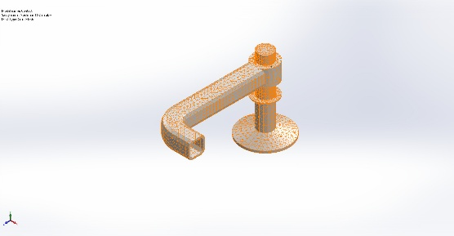 | Entities: 1 face(s)  Units: mm  Size: 2.97281  Ratio: 2.97281
Control-2 | 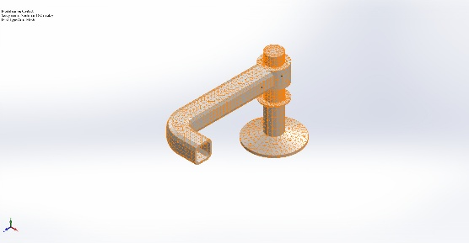 | Entities: 2 face(s)  Units: mm  Size: 4.95468  Ratio: 4.95468
Control-3 | 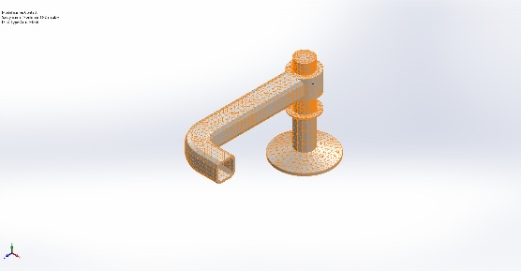 | Entities: 1 face(s)  Units: mm  Size: 3.09668  Ratio: 3.09668

Mesh Quality Plots
Name | Type | Min | Max
Quality1 | Mesh | - | -
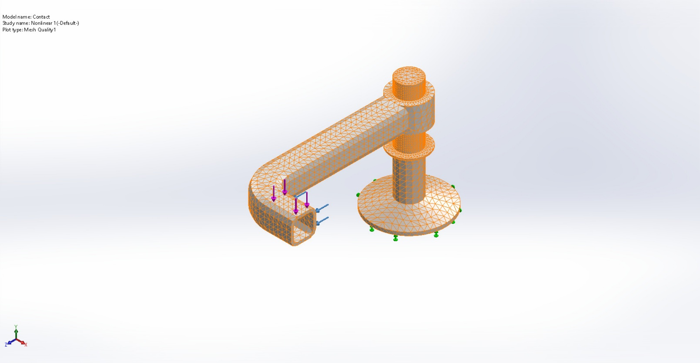
Contact-Nonlinear 1-Quality-Quality1

Sensor Details
No Data

Resultant Forces

Reaction forces
Selection set | Units | Sum X | Sum Y | Sum Z | Resultant
Entire Model | N | 383.769 | 135.727 | -116.037 | 423.279

Reaction Moments
Selection set | Units | Sum X | Sum Y | Sum Z | Resultant
Entire Model | N.m | 0 | 0 | 0 | 0

Free body forces
Selection set | Units | Sum X | Sum Y | Sum Z | Resultant
Entire Model | N | 0 | 0 | 0 | 0

Free body moments
Selection set | Units | Sum X | Sum Y | Sum Z | Resultant
Entire Model | N.m | 0 | 0 | 0 | 0

Beams
No Data

Study Results

Name | Type | Min | Max
Stress1 | VON: von Mises Stress at Step No: 100(0.08 Seconds) | 4.485e+03N/m^2  Node: 1668 | 1.700e+07N/m^2  Node: 719
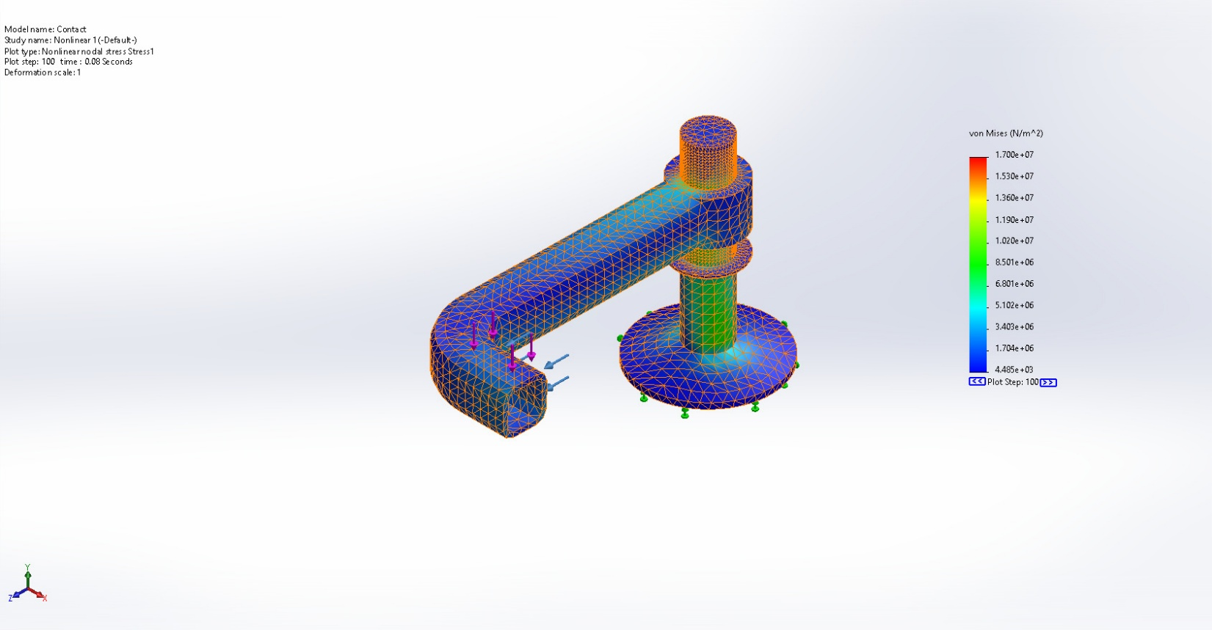
Contact-Nonlinear 1-Stress-Stress1

Name | Type | Min | Max
Displacement1 | URES: Resultant Displacement at Step No: 99(0.0792 Seconds) | 0.000e+00mm  Node: 1479 | 1.018e+01mm  Node: 4471
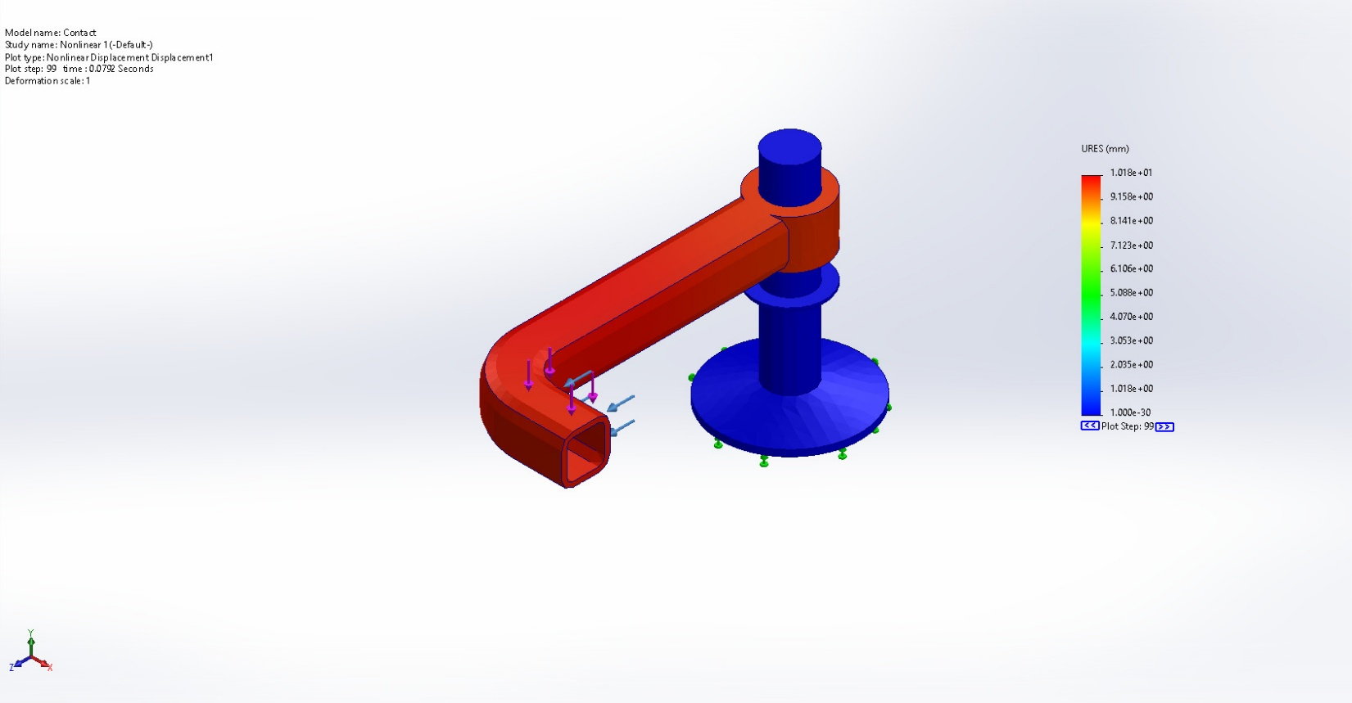
Contact-Nonlinear 1-Displacement-Displacement1

Name | Type | Min | Max
Strain1 | ESTRN: Equivalent Strain at Step No: 100(0.08 Seconds) | 9.749e-09  Element: 1519 | 3.671e-03  Element: 15151
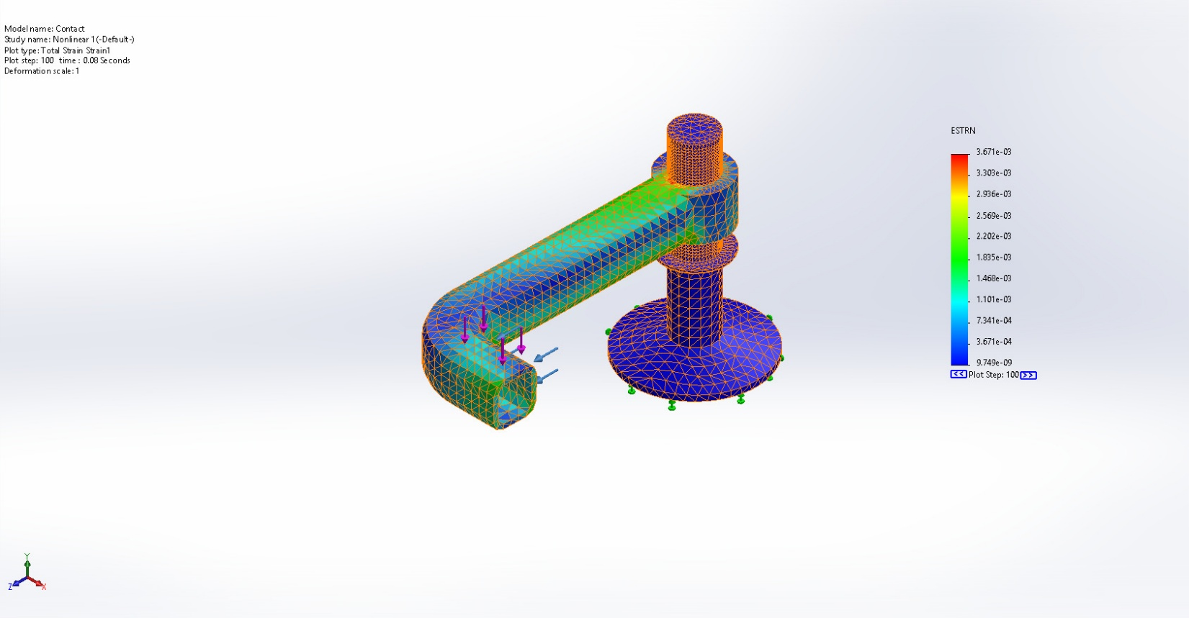
Contact-Nonlinear 1-Strain-Strain1

Name | Type
Response1 | Nonlinear Response
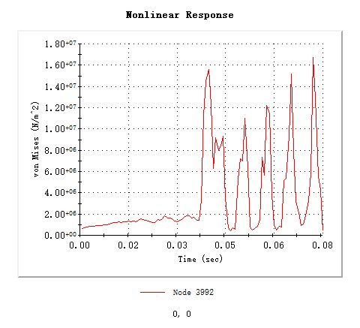
Contact-Nonlinear 1-Response-Response1

Name | Type | Min | Max
Acceleration1 | AY: Y Acceleration at Step No: 54(0.0432 Seconds) | -2.277e+06mm/s^2  Node: 3721 | 4.012e+06mm/s^2  Node: 4229
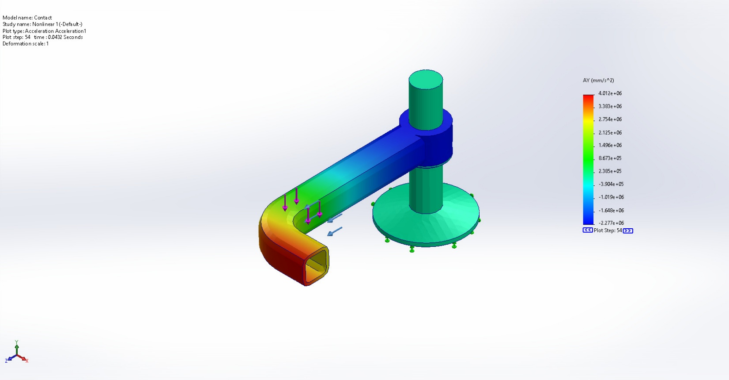
Contact-Nonlinear 1-Acceleration-Acceleration1

Conclusion

